Introduction of Operating System – Set 1

An operating system acts as an intermediary between the user of a computer and computer hardware.
The purpose of an operating system is to provide an environment in which a user can execute programs conveniently and efficiently.
An operating system is software that manages computer hardware. The hardware must provide appropriate mechanisms to ensure the correct operation of the computer system and to prevent user programs from interfering with the proper operation of the system.
A more common definition is that the operating system is the one program running at all times on the computer (usually called the kernel), with all else being application programs.
An operating system is concerned with the allocation of resources and services, such as memory, processors, devices, and information.
The operating system correspondingly includes programs to manage these resources, such as a traffic controller, a scheduler, a memory management module, I/O programs, and a file system.
- History of Operating System
The operating system has been evolving through the years. The following table shows the history of OS.
Generation | Year | Electronic device used | Types of OS Devices
First | 1945-55 | Vacuum Tubes | Plug Boards
Second | 1955-65 | Transistors | Batch Systems
Third | 1965-80 | Integrated Circuits(IC) | Multiprogramming
Fourth | Since 1980 | Large Scale Integration | PC

Characteristics of Operating Systems
Let us now discuss some of the important characteristic features of operating systems:
- Device Management: The operating system keeps track of all the devices. So, it is also called the Input/Output controller that decides which process gets the device, when, and for how much time.
- File Management: It allocates and de-allocates the resources and also decides who gets the resource.
- Job Accounting: It keeps track of time and resources used by various jobs or users.
- Error-detecting Aids: These contain methods that include the production of dumps, traces, error messages, and other debugging and error-detecting methods.
- Memory Management: It keeps track of the primary memory, like what part of it is in use by whom, or what part is not in use, etc. and It also allocates the memory when a process or program requests it.
- Processor Management: It allocates the processor to a process and then de-allocates the processor when it is no longer required or the job is done.
- Control on System Performance: It records the delays between the request for a service and the system.
- Security: It prevents unauthorized access to programs and data using passwords or some kind of protection technique.
- Convenience: An OS makes a computer more convenient to use.
- Efficiency: An OS allows the computer system resources to be used efficiently.
- Ability to Evolve: An OS should be constructed in such a way as to permit the effective development, testing, and introduction of new system functions at the same time without interfering with service.
- Throughput: An OS should be constructed so that It can give maximum throughput (Number of tasks per unit time).

Functionalities of Operating System
- Resource Management: When parallel accessing happens in the OS means when multiple users are accessing the system the OS works as Resource Manager, Its responsibility is to provide hardware to the user. It decreases the load in the system.
- Process Management: It includes various tasks like scheduling and termination of the process. It is done with the help of CPU Scheduling algorithms.
- Storage Management: The file system mechanism used for the management of the storage. NIFS, CIFS, CFS, NFS, etc. are some file systems. All the data is stored in various tracks of Hard disks that are all managed by the storage manager. It included Hard Disk.
- Memory Management: Refers to the management of primary memory. The operating system has to keep track of how much memory has been used and by whom. It has to decide which process needs memory space and how much. OS also has to allocate and deallocate the memory space.
- Security/Privacy Management: Privacy is also provided by the Operating system using passwords so that unauthorized applications can’t access programs or data. For example, Windows uses Kerberos authentication to prevent unauthorized access to data.

The process operating system as User Interface:
- User
- System and application programs
- Operating system
- Hardware
Every general-purpose computer consists of hardware, an operating system(s), system programs, and application programs. The hardware consists of memory, CPU, ALU, I/O devices, peripheral devices, and storage devices. The system program consists of compilers, loaders, editors, OS, etc. The application program consists of business programs and database programs.
Every computer must have an operating system to run other programs. The operating system coordinates the use of the hardware among the various system programs and application programs for various users. It simply provides an environment within which other programs can do useful work.
The operating system is a set of special programs that run on a computer system that allows it to work properly. It performs basic tasks such as recognizing input from the keyboard, keeping track of files and directories on the disk, sending output to the display screen, and controlling peripheral devices.

Purposes and Tasks of Operating Systems
Several tasks are performed by the Operating Systems and it also helps in serving a lot of purposes which are mentioned below. We will see how Operating System helps us in serving in a better way with the help of the task performed by it.rposes of an Operating System
- It controls the allocation and use of the computing System’s resources among the various user and tasks.
- It provides an interface between the computer hardware and the programmer that simplifies and makes it feasible for coding and debugging of application programs.

Tasks of an Operating System
- Provides the facilities to create and modify programs and data files using an editor.
- Access to the compiler for translating the user program from high-level language to machine language.
- Provide a loader program to move the compiled program code to the computer’s memory for execution.
- Provide routines that handle the details of I/O programming.

I/O System Management
The module that keeps track of the status of devices is called the I/O traffic controller. Each I/O device has a device handler that resides in a separate process associated with that device.
The I/O subsystem consists of
- A memory Management component that includes buffering caching and spooling.
- A general device driver interface.

Drivers for Specific Hardware Devices
Below mentioned are the drivers which are required for a specific Hardware Device. Here we discussed Assemblers, compilers, and interpreters, loaders.

Assembler
The input to an assembler is an assembly language program. The output is an object program plus information that enables the loader to prepare the object program for execution. At one time, the computer programmer had at his disposal a basic machine that interpreted, through hardware, certain fundamental instructions. He would program this computer by writing a series of ones and Zeros (Machine language) and placing them into the memory of the machine. Examples of assembly languages include
Compiler and Interpreter
The High-level languages– examples are C, C++, Java, Python, etc (around 300+ famous high-level languages) are processed by compilers and interpreters. A compiler is a program that accepts a source program in a “high-level language “and produces machine code in one go. Some of the compiled languages are FORTRAN, COBOL, C, C++, Rust, and Go. An interpreter is a program that does the same thing but converts high-level code to machine code line-by-line and not all at once. Examples of interpreted languages are
- Python
- Perl
- Ruby

Loader
A Loader is a routine that loads an object program and prepares it for execution. There are various loading schemes: absolute, relocating, and direct-linking. In general, the loader must load, relocate and link the object program. The loader is a program that places programs into memory and prepares them for execution. In a simple loading scheme, the assembler outputs the machine language translation of a program on a secondary device and a loader places it in the core. The loader places into memory the machine language version of the user’s program and transfers control to it. Since the loader program is much smaller than the assembler, those make more core available to the user’s program.

Components of an Operating Systems
There are two basic components of an Operating System.
- Shell
- Kernel

Shell
Shell is the outermost layer of the Operating System and it handles the interaction with the user.
The main task of the Shell is the management of interaction between the User and OS. Shell provides better communication with the user and the Operating System Shell does it by giving proper input to the user it also interprets input for the OS and handles the output from the OS. It works as a way of communication between the User and the OS.

Kernel
The kernel is one of the components of the Operating System which works as a core component. The rest of the components depends on Kernel for the supply of the important services that are provided by the Operating System. The kernel is the primary interface between the Operating system and Hardware.

Functions of Kernel
The following functions are to be performed by the Kernel.
- It helps in controlling the System Calls.
- It helps in I/O Management.
- It helps in the management of applications, memory, etc.

Types of Kernel
There are four types of Kernel that are mentioned below.
- Monolithic Kernel
- Microkernel
- Hybrid Kernel
- Exokernel
For more, refer to Kernel in Operating System.
Difference Between 32-Bit and 64-Bit Operating Systems
32-Bit Operating System | 64-Bit Operating System
32-Bit OS is required for running of 32-Bit Processors, as they are not capable of running on 64-bit processors. | 64-Bit Processors can run on any of the Operating Systems, like 32-Bit OS or 64-Bit OS.
32-Bit OS gives a low efficient performance. | 64-Bit Operating System provides highly efficient Performance.
Less amount of data is managed in 32-Bit Operating System as compared to 64-Bit Os. | A large amount of data can be stored in 64-Bit Operating System.
32-Bit Operating System can address 2^32 bytes of RAM. | 64-Bit Operating System can address 2^64 bytes of RAM.

Advantages of Operating System
- It helps in managing the data present in the device i.e. Memory Management.
- It helps in making the best use of computer hardware.
- It helps in maintaining the security of the device.
- It helps different applications in running them efficiently.

Disadvantages of Operating System
- Operating Systems can be difficult for someone to use.
- Some OS are expensive and they require heavy maintenance.
- Operating Systems can come under threat if used by hackers.

FAQs

1. Explain Operating System.
Answer:
The operating system can be explained as the intermediate, which works between the user and the system hardware so that the user can get a nice experience while using a system. Without an Operating system, there will be a lot of difficulties can be faced by the user while running a system.

2. What are the types of operating Systems?
Answer:
The types of Operating systems are listed below.
- Batch Operating System
- Multi-Programming System
- Multi-Processing System
- Multi-Tasking Operating System
- Time-Sharing Operating System
- Distributed Operating System
- Network Operating System
- Real-Time Operating System

3. What is the importance of an Operating System?
Answer:
The operating system is one of the most important parts of a Computer System. Without an Operating System, the system will not be able to work. As Operating System works as an interpreter between the user and the hardware part, which helps in the smooth functioning of the system.

4. What is an OS Structure?
Answer:
Operating System structure is basically the model in which the system works. The structure of the operating system should be user-friendly, such that if any user having less knowledge about the system comes then he/she will not face any difficulties while running the system.

5. What do you mean by a process in Operating System?
Answer:
A process can be simply defined as the instance of a computer. The process always includes the program code and its operations both. The process also includes the threads running in the computer system. It can be a single thread or a multiple thread.

Views of Operating System
An operating system is a framework that enables user application programs to interact with system hardware. The operating system does not perform any functions on its own, but it provides an atmosphere in which various apps and programs can do useful work. The operating system may be observed from the point of view of the user or the system, and it is known as the user view and the system view. In this article, you will learn the views of the operating system.

Viewpoints of Operating System
The operating system may be observed from the viewpoint of the user or the system. It is known as the user view and the system view. There are mainly two types of views of the operating system. These are as follows:
- User View
- System View

User View
The user view depends on the system interface that is used by the users. Some systems are designed for a single user to monopolize the resources to maximize the user's task. In these cases, the OS is designed primarily for ease of use, with little emphasis on quality and none on resource utilization.
The user viewpoint focuses on how the user interacts with the operating system through the usage of various application programs. In contrast, the system viewpoint focuses on how the hardware interacts with the operating system to complete various tasks.
1. Single User View Point
Most computer users use a monitor, keyboard, mouse, printer, and other accessories to operate their computer system. In some cases, the system is designed to maximize the output of a single user. As a result, more attention is laid on accessibility, and resource allocation is less important. These systems are much more designed for a single user experience and meet the needs of a single user, where the performance is not given focus as the multiple user systems.

2. Multiple User View Point
Another example of user views in which the importance of user experience and performance is given is when there is one mainframe computer and many users on their computers trying to interact with their kernels over the mainframe to each other. In such circumstances, memory allocation by the CPU must be done effectively to give a good user experience. The client-server architecture is another good example where many clients may interact through a remote server, and the same constraints of effective use of server resources may arise.
3. Handled User View Point
Moreover, the touchscreen era has given you the best handheld technology ever. Smartphones interact via wireless devices to perform numerous operations, but they're not as efficient as a computer interface, limiting their usefulness. However, their operating system is a great example of creating a device focused on the user's point of view.
4. Embedded System User View Point
Some systems, like embedded systems that lack a user point of view. The remote control used to turn on or off the tv is all part of an embedded system in which the electronic device communicates with another program where the user viewpoint is limited and allows the user to engage with the application.

System View
The OS may also be viewed as just a resource allocator. A computer system comprises various sources, such as hardware and software, which must be managed effectively. The operating system manages the resources, decides between competing demands, controls the program execution, etc. According to this point of view, the operating system's purpose is to maximize performance. The operating system is responsible for managing hardware resources and allocating them to programs and users to ensure maximum performance.
From the user point of view, we've discussed the numerous applications that require varying degrees of user participation. However, we are more concerned with how the hardware interacts with the operating system than with the user from a system viewpoint. The hardware and the operating system interact for a variety of reasons, including:

1. Resource Allocation
The hardware contains several resources like registers, caches, RAM, ROM, CPUs, I/O interaction, etc. These are all resources that the operating system needs when an application program demands them. Only the operating system can allocate resources, and it has used several tactics and strategies to maximize its processing and memory space. The operating system uses a variety of strategies to get the most out of the hardware resources, including paging, virtual memory, caching, and so on. These are very important in the case of various user viewpoints because inefficient resource allocation may affect the user viewpoint, causing the user system to lag or hang, reducing the user experience.
2. Control Program
The control program controls how input and output devices (hardware) interact with the operating system. The user may request an action that can only be done with I/O devices; in this case, the operating system must also have proper communication, control, detect, and handle such devices.

Types of Operating Systems (OS)
An operating system is a well-organized collection of programs that manages the computer hardware. It is a type of system software that is responsible for the smooth functioning of the computer system.
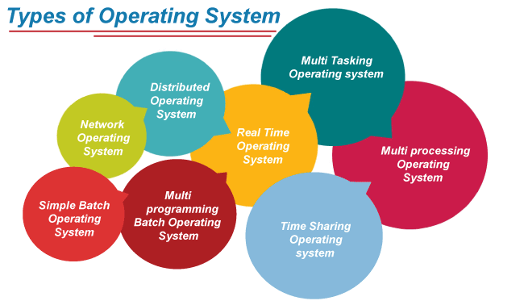

Batch Operating System
In the beginning, computers were extremely large machines that ran from a console. In general, tape drivers or card readers were used for input, and tape drives, punch cards, and line printers were used for output. Users had no direct interface with the system, and job execution was done in a batch system. These systems are known as batched operating systems, and users have to prepare a job separately to execute it.
There were no developed operating systems, complex computer architecture, or secondary memory devices in the 1950s and 1960s. Instead, large mainframe computers were used to process data, with punched cards or magnetic tapes serving as input and output. The primary problem at the time was a lack of hard disks.
In the early 1950s, General Motors Research Laboratories (GMRL) introduced the first Single-Stream batch processing systems. It only executed one job at a time, and data was sent in batches or groups. The batch operating system eliminates the setup time issue.
In this article, you will learn about the batch operating system, types, working, and its advantages and disadvantages.

What is Batch Operating System?
Batch processing was very popular in the 1970s. The jobs were executed in batches. People used to have a single computer known as a mainframe. Users using batch operating systems do not interact directly with the computer. Each user prepares their job using an offline device like a punch card and submitting it to the computer operator. Jobs with similar requirements are grouped and executed as a group to speed up processing. Once the programmers have left their programs with the operator, they sort the programs with similar needs into batches.
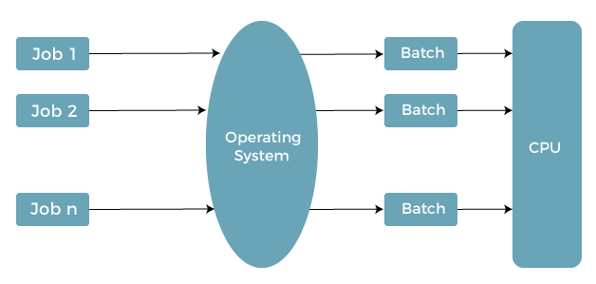
The batch operating system grouped jobs that perform similar functions. These job groups are treated as a batch and executed simultaneously. A computer system with this operating system performs the following batch processing activities:
- A job is a single unit that consists of a preset sequence of commands, data, and programs.
- Processing takes place in the order in which they are received, i.e., first come, first serve.
- These jobs are stored in memory and executed without the need for manual information.
- When a job is successfully run, the operating system releases its memory.

Types of Batch Operating System
There are mainly two types of the batch operating system. These are as follows:
- Simple Batched System
- Multi-programmed batched system

Simple Batched System
The user did not directly interact with the computer system for job execution in a simple batch operating system. However, the user was required to prepare a job that included the program, control information, and data on the nature of the job on control cards. The job was then submitted to the computer operator, who was usually in the form of a punch card. The program's output included results and registers and memory dumps in the event of a program error. The output appeared after some time that could take days, hours, and minutes.
Its main role was to transfer control from one job to another. Jobs with similar requirements were pooled together and processed through the processor to improve processing speed. The operators were used in the program to create batches with similar needs. The computer runs the batches one by one when they became available. This system typically reads a sequence of jobs, each with its control cads and predefined job tasks.

Multi-programmed batched system
Spooling deals with many jobs that have already been read and are waiting to run on disk.
A disk containing a pool of jobs allows the operating system to choose which job to run next to maximize CPU utilization.
Jobs that come on magnetic tape or cards directly cannot be run in a different order. Jobs run sequentially because they are executed in a first-come, first-served manner.
When various jobs are stored on a direct access device, job scheduling becomes possible like a disk. Multi-programming is an important feature of job scheduling. For overlapped I/O, spooling and offline operations have their limitations. Generally, a single user could not maintain all of the input/output devices, and CPU buys at all times.
In the multi-programmed batched system, jobs are grouped so that the CPU only executes one job at a time to improve CPU utilization. The operating system maintains various jobs in memory at a time. The operating system selects one job and begins executing it in memory. Finally, the job must wait for a task to complete, such as mounting a tape on an I/O operation. In a multiprogramming system, do not sit idle because the operating system switches to another task. When a job is in the wait state, and the current job is completed, the CPU is returned.

Why are Batch Operating Systems used?
Batch operating systems load less stress on the CPU and include minimal user interaction, and that is why you can still use them nowadays. Another benefit of batch operating systems is that huge repetitive jobs may be done without interacting with the computer to notify the system that you need to perform after you finish that job.
Old batch operating systems weren't interactive, which means that the user did not interact with the program while executing it. Modern batch operating systems now support interactions. For example, you may schedule the job, and when the specified time arrives, the computer acknowledges the processor that the time is up.

How does Batch Operating System work?
The operating system keeps the number of jobs in memory and performs them one at a time. Jobs are processed in a first-come, first-served manner. Each job set is defined as a batch. When a task is finished, its memory is freed, and the work's output is transferred into an output spool for later printing or processing. User interaction is limited in the batch operating system. When the system takes the task from the user, user is free. You may also use the batch processing system to update data relating to any transactions or records.

Role of Batch Operating System
A batch operating system's primary role is to execute jobs in batches automatically. The main task of a batch processing system is done by the 'Batch Monitor', which is located at the low end of the main memory. This technique was made possible by the development of hard disk drives and card readers. The jobs can now be stored on a disk to form a pool of jobs for batch execution. After that, they are grouped with similar jobs being placed in the same batch. As a result, the batch operating system automatically ran the batched jobs one after the other, saving time by performing tasks only once. It resulted from a better system due to reduced turnaround time.

Characteristics of Batch Operating System
There are various characteristics of the Batch Operating System. Some of them are as follows:
- In this case, the CPU executes the jobs in the same sequence that they are sent to it by the operator, which implies that the task sent to the CPU first will be executed first. It's also known as the 'first come, first serve'
- The word job refers to the command or instruction that the user and the program should perform.
- A batch operating system runs a set of user-supplied instructions composed of distinct instructions and programs with several similarities.
- When a task is successfully executed, the OS releases the memory space held by that job.
- The user does not interface directly with the operating system in a batch operating system; rather, all instructions are sent to the operator.
- The operator evaluates the user's instructions and creates a set of instructions having similar properties.

Advantages and Disadvantages of Batch Operating System
There are various advantages and disadvantages of the Batch Operating System. Some of them are as follows:

Advantages
There are various advantages of the Batch Operating System. Some of them are as follows:
- It isn't easy to forecast how long it will take to complete a job; only batch system processors know how long it will take to finish the job in line.
- This system can easily manage large jobs again and again.
- The batch process can be divided into several stages to increase processing speed.
- When a process is finished, the next job from the job spool is run without any user interaction.
- CPU utilization gets improved.

Disadvantages
There are various disadvantages of the Batch Operating System. Some of them are as follows:
- When a job fails once, it must be scheduled to be completed, and it may take a long time to complete the task.
- Computer operators must have full knowledge of batch systems.
- The batch system is quite difficult to debug.
- The computer system and the user have no direct interaction.
- If a job enters an infinite loop, other jobs must wait for an unknown period of time.

Multiprogramming Operating System
In this article, you will learn about the multiprogramming operating system, its working, advantages, and disadvantages.

What is the Multiprogramming Operating System?
A multiprogramming operating system may run many programs on a single processor computer. If one program must wait for an input/output transfer in a multiprogramming operating system, the other programs are ready to use the CPU. As a result, various jobs may share CPU time. However, the execution of their jobs is not defined to be at the same time period.
When a program is being performed, it is known as a "Task", "Process", and "Job". Concurrent program executions improve system resource consumption and throughput as compared to serial and batch processing systems.
The primary goal of multiprogramming is to manage the entire system's resources. The key components of a multiprogramming system are the file system, command processor, transient area, and I/O control system. As a result, multiprogramming operating systems are designed to store different programs based on sub-segmenting parts of the transient area. The resource management routines are linked with the operating system core functions.

Types of the Multiprogramming Operating System
There are mainly two types of multiprogramming operating systems. These are as follows:
- Multitasking Operating System
- Multiuser Operating System

Multitasking Operating System
A multitasking operating system enables the execution of two or more programs at the same time. The operating system accomplishes this by shifting each program into and out of memory one at a time. When a program is switched out of memory, it is temporarily saved on disk until it is required again.

Multiuser Operating System
A multiuser operating system allows many users to share processing time on a powerful central computer from different terminals. The operating system accomplishes this by rapidly switching between terminals, each of which receives a limited amount of processor time on the central computer. The operating system changes among terminals so quickly that each user seems to have continuous access to the central computer. If there are many users on a system like this, the time it takes the central computer to reply can become more obvious.

Working of the Multiprogramming Operating System
Multiple users can accomplish their jobs simultaneously in the multiprogramming system, and it can be stored in the main memory. When one program is engaged in I/O operations, the CPU may deliver time to various programs while sitting in idle mode.
When one application is waiting for an I/O transfer, another is ready to use the processor at all times, and numerous programs may share CPU time. All jobs are not run simultaneously, but there could be numerous jobs running on the processor at the same time, and parts of other processes being executed first, then another segment, etc. As a result, the overall goal of a multiprogramming system is to keep the CPU busy until some tasks are available in the job pool. Thus, the numerous programs can run on a single processor computer, and the CPU is never idle.

Examples of Multiprogramming Operating System
There are various examples of multiprogramming operating systems, including download apps, transfer data, MS-Excel, Google Chrome, Firefox browser, and many more apps. Other examples are Windows O/S, UNIX O/S, Microcomputers such as XENIX, MP/M, and ESQview.

Advantages and Disadvantages of Multiprogramming Operating System
There are various advantages and disadvantages of the multiprogramming operating system. Some of the advantages and disadvantages are as follows:

Advantages
There are various advantages of the multiprogramming operating system. Some of the advantages are as follows:
- It provides less response time.
- It may help to run various jobs in a single application simultaneously.
- It helps to optimize the total job throughput of the computer.
- Various users may use the multiprogramming system at once.
- Short-time jobs are done quickly in comparison to long-time jobs.
- It may help to improve turnaround time for short-time tasks.
- It helps in improving CPU utilization and never gets idle.
- The resources are utilized smartly.

Disadvantages
There are various disadvantages of the multiprogramming operating system. Some of the disadvantages are as follows:
- It is highly complicated and sophisticated.
- The CPU scheduling is required.
- Memory management is needed in the operating system because all types of tasks are stored in the main memory.
- The harder task is to handle all processes and tasks.
- If it has a large number of jobs, then long-term jobs will require a long wait.

Time-Sharing Operating System
In the Time Sharing operating system, computer resources are allocated in a time-dependent fashion to several programs simultaneously. Thus it helps to provide a large number of user's direct access to the main computer. It is a logical extension of multiprogramming. In time-sharing, the CPU is switched among multiple programs given by different users on a scheduled basis.
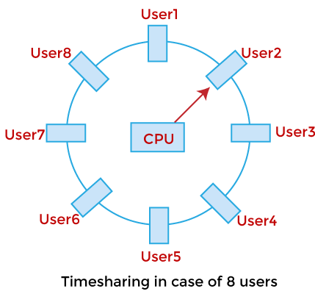
A time-sharing operating system allows many users to be served simultaneously, so sophisticated CPU scheduling schemes and Input/output management are required.
Time-sharing operating systems are very difficult and expensive to build.

Advantages of Time Sharing Operating System
- The time-sharing operating system provides effective utilization and sharing of resources.
- This system reduces CPU idle and response time.

Disadvantages of Time Sharing Operating System
- Data transmission rates are very high in comparison to other methods.
- Security and integrity of user programs loaded in memory and data need to be maintained as many users access the system at the same time.

Multiprocessing Operating system
In operating systems, to improve the performance of more than one CPU can be used within one computer system called Multiprocessor operating system.
Multiple CPUs are interconnected so that a job can be divided among them for faster execution. When a job finishes, results from all CPUs are collected and compiled to give the final output. Jobs needed to share main memory and they may also share other system resources among themselves. Multiple CPUs can also be used to run multiple jobs simultaneously.
For Example: UNIX Operating system is one of the most widely used multiprocessing systems.
The basic organization of a typical multiprocessing system is shown in the given figure.
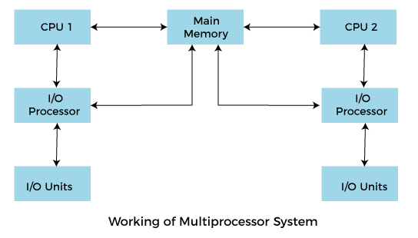
To employ a multiprocessing operating system effectively, the computer system must have the following things:
- A motherboard is capable of handling multiple processors in a multiprocessing operating system.
- Processors are also capable of being used in a multiprocessing system.

Advantages of multiprocessing operating system are:
- Increased reliability: Due to the multiprocessing system, processing tasks can be distributed among several processors. This increases reliability as if one processor fails; the task can be given to another processor for completion.
- Increased throughout: As several processors increase, more work can be done in less
- The economy of Scale: As multiprocessors systems share peripherals, secondary storage devices, and power supplies, they are relatively cheaper than single-processor systems.

Disadvantages of Multiprocessing operating System
- Operating system of multiprocessing is more complex and sophisticated as it takes care of multiple CPUs at the same time.

Types of multiprocessing systems
- Symmetrical multiprocessing operating system
- Asymmetric multiprocessing operating system

Symmetrical multiprocessing operating system:
In a Symmetrical multiprocessing system, each processor executes the same copy of the operating system, takes its own decisions, and cooperates with other processes to smooth the entire functioning of the system. The CPU scheduling policies are very simple. Any new job submitted by a user can be assigned to any processor that is least burdened. It also results in a system in which all processors are equally burdened at any time.
The symmetric multiprocessing operating system is also known as a "shared every-thing" system, because the processors share memory and the Input output bus or data path. In this system processors do not usually exceed more than 16.
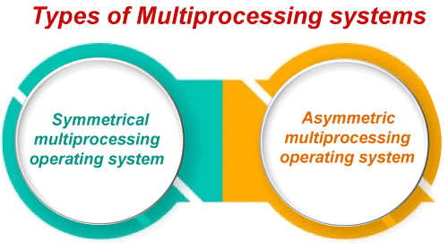
Characteristics of Symmetrical multiprocessing operating system:
- In this system, any processor can run any job or process.
- In this, any processor initiates an Input and Output operation.
Advantages of Symmetrical multiprocessing operating system:
- These systems are fault-tolerant. Failure of a few processors does not bring the entire system to a halt.
Disadvantages of Symmetrical multiprocessing operating system:
- It is very difficult to balance the workload among processors rationally.
- Specialized synchronization schemes are necessary for managing multiple processors.

Asymmetric multiprocessing operating system
In an asymmetric multiprocessing system, there is a master slave relationship between the processors.
Further, one processor may act as a master processor or supervisor processor while others are treated as shown below.
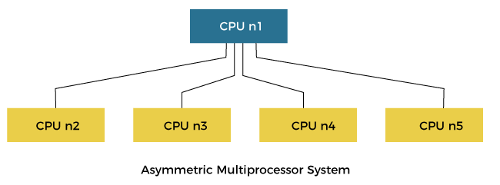
In the above figure, the asymmetric processing system shows that CPU n1 acts as a supervisor whose function controls other following processors.
In this type of system, each processor is assigned a specific task, and there is a designated master processor that controls the activities of other processors.
For example, we have a math co-processor that can handle mathematical jobs better than the main CPU. Similarly, we have an MMX processor that is built to handle multimedia-related jobs. Similarly, we have a graphics processor to handle the graphics-related job better than the main processor. When a user submits a new job, the OS has to decide which processor can perform it better, and then that processor is assigned that newly arrived job. This processor acts as the master and controls the system. All other processors look for masters for instructions or have predefined tasks. It is the responsibility of the master to allocate work to other processors.
Advantages of Asymmetric multiprocessing operating system:
- In this type of system execution of Input and Output operation or an application program may be faster in some situations because many processors may be available for a single job.
Disadvantages of Asymmetric multiprocessing operating system:
- In this type of multiprocessing operating system the processors are unequally burdened. One processor may be having a long job queue, while another one may be sitting idle.
- In this system, if the process handling a specific work fails, the entire system will go down.

Distributed Operating System
A distributed operating system (DOS) is an essential type of operating system. Distributed systems use many central processors to serve multiple real-time applications and users. As a result, data processing jobs are distributed between the processors.
It connects multiple computers via a single communication channel. Furthermore, each of these systems has its own processor and memory. Additionally, these CPUs communicate via high-speed buses or telephone lines. Individual systems that communicate via a single channel are regarded as a single entity. They're also known as loosely coupled systems.
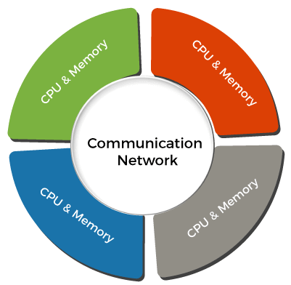
This operating system consists of numerous computers, nodes, and sites joined together via LAN/WAN lines. It enables the distribution of full systems on a couple of center processors, and it supports many real-time products and different users. Distributed operating systems can share their computing resources and I/O files while providing users with virtual machine abstraction.

Types of Distributed Operating System
There are various types of Distributed Operating systems. Some of them are as follows:
- Client-Server Systems
- Peer-to-Peer Systems
- Middleware
- Three-tier
- N-tier

Client-Server System
This type of system requires the client to request a resource, after which the server gives the requested resource. When a client connects to a server, the server may serve multiple clients at the same time.
Client-Server Systems are also referred to as "Tightly Coupled Operating Systems". This system is primarily intended for multiprocessors and homogenous multicomputer. Client-Server Systems function as a centralized server since they approve all requests issued by client systems.
Server systems can be divided into two parts:
1. Computer Server System
This system allows the interface, and the client then sends its own requests to be executed as an action. After completing the activity, it sends a back response and transfers the result to the client.
2. File Server System
It provides a file system interface for clients, allowing them to execute actions like file creation, updating, deletion, and more.

Peer-to-Peer System
The nodes play an important role in this system. The task is evenly distributed among the nodes. Additionally, these nodes can share data and resources as needed. Once again, they require a network to connect.
The Peer-to-Peer System is known as a "Loosely Couple System". This concept is used in computer network applications since they contain a large number of processors that do not share memory or clocks. Each processor has its own local memory, and they interact with one another via a variety of communication methods like telephone lines or high-speed buses.

Middleware
Middleware enables the interoperability of all applications running on different operating systems. Those programs are capable of transferring all data to one other by using these services.

Three-tier
The information about the client is saved in the intermediate tier rather than in the client, which simplifies development. This type of architecture is most commonly used in online applications.

N-tier
When a server or application has to transmit requests to other enterprise services on the network, n-tier systems are used.

Features of Distributed Operating System
There are various features of the distributed operating system. Some of them are as follows:
Openness
It means that the system's services are freely displayed through interfaces. Furthermore, these interfaces only give the service syntax. For example, the type of function, its return type, parameters, and so on. Interface Definition Languages are used to create these interfaces (IDL).
Scalability
It refers to the fact that the system's efficiency should not vary as new nodes are added to the system. Furthermore, the performance of a system with 100 nodes should be the same as that of a system with 1000 nodes.
Resource Sharing
Its most essential feature is that it allows users to share resources. They can also share resources in a secure and controlled manner. Printers, files, data, storage, web pages, etc., are examples of shared resources.
Flexibility
A DOS's flexibility is enhanced by modular qualities and delivers a more advanced range of high-level services. The kernel/ microkernel's quality and completeness simplify the implementation of such services.
Transparency
It is the most important feature of the distributed operating system. The primary purpose of a distributed operating system is to hide the fact that resources are shared. Transparency also implies that the user should be unaware that the resources he is accessing are shared. Furthermore, the system should be a separate independent unit for the user.
Heterogeneity
The components of distributed systems may differ and vary in operating systems, networks, programming languages, computer hardware, and implementations by different developers.
Fault Tolerance
Fault tolerance is that process in which user may continue their work if the software or hardware fails.

Examples of Distributed Operating System
There are various examples of the distributed operating system. Some of them are as follows:
Solaris
It is designed for the SUN multiprocessor workstations
OSF/1
It's compatible with Unix and was designed by the Open Foundation Software Company.
Micros
The MICROS operating system ensures a balanced data load while allocating jobs to all nodes in the system.
DYNIX
It is developed for the Symmetry multiprocessor computers.
Locus
It may be accessed local and remote files at the same time without any location hindrance.
Mach
It allows the multithreading and multitasking features.

Applications of Distributed Operating System
There are various applications of the distributed operating system. Some of them are as follows:
Network Applications
DOS is used by many network applications, including the Web, peer-to-peer networks, multiplayer web-based games, and virtual communities.
Telecommunication Networks
DOS is useful in phones and cellular networks. A DOS can be found in networks like the Internet, wireless sensor networks, and routing algorithms.
Parallel Computation
DOS is the basis of systematic computing, which includes cluster computing and grid computing, and a variety of volunteer computing projects.
Real-Time Process Control
The real-time process control system operates with a deadline, and such examples include aircraft control systems.

Advantages and Disadvantages of Distributed Operating System
There are various advantages and disadvantages of the distributed operating system. Some of them are as follows:

Advantages
There are various advantages of the distributed operating system. Some of them are as follow:
- It may share all resources (CPU, disk, network interface, nodes, computers, and so on) from one site to another, increasing data availability across the entire system.
- It reduces the probability of data corruption because all data is replicated across all sites; if one site fails, the user can access data from another operational site.
- The entire system operates independently of one another, and as a result, if one site crashes, the entire system does not halt.
- It increases the speed of data exchange from one site to another site.
- It is an open system since it may be accessed from both local and remote locations.
- It helps in the reduction of data processing time.
- Most distributed systems are made up of several nodes that interact to make them fault-tolerant. If a single machine fails, the system remains operational.

Disadvantages
There are various disadvantages of the distributed operating system. Some of them are as follows:
- The system must decide which jobs must be executed when they must be executed, and where they must be executed. A scheduler has limitations, which can lead to underutilized hardware and unpredictable runtimes.
- It is hard to implement adequate security in DOS since the nodes and connections must be secured.
- The database connected to a DOS is relatively complicated and hard to manage in contrast to a single-user system.
- The underlying software is extremely complex and is not understood very well compared to other systems.
- The more widely distributed a system is, the more communication latency can be expected. As a result, teams and developers must choose between availability, consistency, and latency.
- These systems aren't widely available because they're thought to be too expensive.
- Gathering, processing, presenting, and monitoring hardware use metrics for big clusters can be a real issue.

Real-Time operating system
In this article, we understand the real time operating system in detail.
What do you mean by Real-Time Operating System?
A real-time operating system (RTOS) is a special-purpose operating system used in computers that has strict time constraints for any job to be performed. It is employed mostly in those systems in which the results of the computations are used to influence a process while it is executing. Whenever an event external to the computer occurs, it is communicated to the computer with the help of some sensor used to monitor the event. The sensor produces the signal that is interpreted by the operating system as an interrupt. On receiving an interrupt, the operating system invokes a specific process or a set of processes to serve the interrupt.
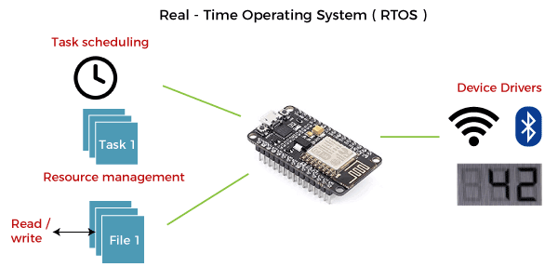
This process is completely uninterrupted unless a higher priority interrupt occurs during its execution. Therefore, there must be a strict hierarchy of priority among the interrupts. The interrupt with the highest priority must be allowed to initiate the process , while lower priority interrupts should be kept in a buffer that will be handled later. Interrupt management is important in such an operating system.
Real-time operating systems employ special-purpose operating systems because conventional operating systems do not provide such performance.
The various examples of Real-time operating systems are:
- MTS
- Lynx
- QNX
- VxWorks etc.
Applications of Real-time operating system (RTOS):
RTOS is used in real-time applications that must work within specific deadlines. Following are the common areas of applications of Real-time operating systems are given below.
- Real-time running structures are used inside the Radar gadget.
- Real-time running structures are utilized in Missile guidance.
- Real-time running structures are utilized in on line inventory trading.
- Real-time running structures are used inside the cell phone switching gadget.
- Real-time running structures are utilized by Air site visitors to manipulate structures.
- Real-time running structures are used in Medical Imaging Systems.
- Real-time running structures are used inside the Fuel injection gadget.
- Real-time running structures are used inside the Traffic manipulate gadget.
- Real-time running structures are utilized in Autopilot travel simulators.

Types of Real-time operating system
Following are the three types of RTOS systems are:
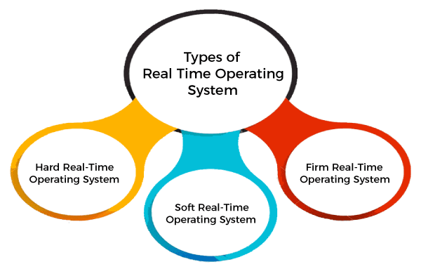
Hard Real-Time operating system:
In Hard RTOS, all critical tasks must be completed within the specified time duration, i.e., within the given deadline. Not meeting the deadline would result in critical failures such as damage to equipment or even loss of human life.
For Example,
Let's take an example of airbags provided by carmakers along with a handle in the driver's seat. When the driver applies brakes at a particular instance, the airbags grow and prevent the driver's head from hitting the handle. Had there been some delay even of milliseconds, then it would have resulted in an accident.
Similarly, consider an on-stock trading software. If someone wants to sell a particular share, the system must ensure that command is performed within a given critical time. Otherwise, if the market falls abruptly, it may cause a huge loss to the trader.
Soft Real-Time operating system:
Soft RTOS accepts a few delays via the means of the Operating system. In this kind of RTOS, there may be a closing date assigned for a particular job, but a delay for a small amount of time is acceptable. So, cut off dates are treated softly via means of this kind of RTOS.
For Example,
This type of system is used in Online Transaction systems and Livestock price quotation Systems.
Firm Real-Time operating system:
In Firm RTOS additionally want to observe the deadlines. However, lacking a closing date might not have a massive effect, however may want to purposely undesired effects, like a massive discount within the fine of a product.
For Example, this system is used in various forms of Multimedia applications.
Advantages of Real-time operating system:
The benefits of real-time operating system are as follows-:
- Easy to layout, develop and execute real-time applications under the real-time operating system.
- The real-time working structures are extra compact, so those structures require much less memory space.
- In a Real-time operating system, the maximum utilization of devices and systems.
- Focus on running applications and less importance to applications that are in the queue.
- Since the size of programs is small, RTOS can also be embedded systems like in transport and others.
- These types of systems are error-free.
- Memory allocation is best managed in these types of systems.
Disadvantages of Real-time operating system:
The disadvantages of real-time operating systems are as follows-
- Real-time operating systems have complicated layout principles and are very costly to develop.
- Real-time operating systems are very complex and can consume critical CPU cycles.

Mobile Operating System
A mobile operating system is an operating system that helps to run other application software on mobile devices. It is the same kind of software as the famous computer operating systems like Linux and Windows, but now they are light and simple to some extent.
The operating systems found on smartphones include Symbian OS, iPhone OS, RIM's BlackBerry, Windows Mobile, Palm WebOS, Android, and Maemo. Android, WebOS, and Maemo are all derived from Linux. The iPhone OS originated from BSD and NeXTSTEP, which are related to Unix.
It combines the beauty of computer and hand use devices. It typically contains a cellular built-in modem and SIM tray for telephony and internet connections. If you buy a mobile, the manufacturer company chooses the OS for that specific device.

Popular platforms of the Mobile OS
1. Android OS: The Android operating system is the most popular operating system today. It is a mobile OS based on the Linux Kernel and open-source software. The android operating system was developed by Google. The first Android device was launched in 2008.
2. Bada (Samsung Electronics): Bada is a Samsung mobile operating system that was launched in 2010. The Samsung wave was the first mobile to use the bada operating system. The bada operating system offers many mobile features, such as 3-D graphics, application installation, and multipoint-touch.
3. BlackBerry OS: The BlackBerry operating system is a mobile operating system developed by Research In Motion (RIM). This operating system was designed specifically for BlackBerry handheld devices. This operating system is beneficial for the corporate users because it provides synchronization with Microsoft Exchange, Novell GroupWise email, Lotus Domino, and other business software when used with the BlackBerry Enterprise Server.
4. iPhone OS / iOS: The iOS was developed by the Apple inc for the use on its device. The iOS operating system is the most popular operating system today. It is a very secure operating system. The iOS operating system is not available for any other mobiles.
5. Symbian OS: Symbian operating system is a mobile operating system that provides a high-level of integration with communication. The Symbian operating system is based on the java language. It combines middleware of wireless communications and personal information management (PIM) functionality. The Symbian operating system was developed by Symbian Ltd in 1998 for the use of mobile phones. Nokia was the first company to release Symbian OS on its mobile phone at that time.
6. Windows Mobile OS: The window mobile OS is a mobile operating system that was developed by Microsoft. It was designed for the pocket PCs and smart mobiles.
7. Harmony OS: The harmony operating system is the latest mobile operating system that was developed by Huawei for the use of its devices. It is designed primarily for IoT devices.
8. Palm OS: The palm operating system is a mobile operating system that was developed by Palm Ltd for use on personal digital assistants (PADs). It was introduced in 1996. Palm OS is also known as the Garnet OS.
9. WebOS (Palm/HP): The WebOS is a mobile operating system that was developed by Palm. It based on the Linux Kernel. The HP uses this operating system in its mobile and touchpads.

Android Operating System
Android is a mobile operating system based on a modified version of the Linux kernel and other open-source software, designed primarily for touchscreen mobile devices such as smartphones and tablets. Android is developed by a partnership of developers known as the Open Handset Alliance and commercially sponsored by Google. It was disclosed in November 2007, with the first commercial Android device, the HTC Dream, launched in September 2008.
It is free and open-source software. Its source code is Android Open Source Project (AOSP), primarily licensed under the Apache License. However, most Android devices dispatch with additional proprietary software pre-installed, mainly Google Mobile Services (GMS), including core apps such as Google Chrome, the digital distribution platform Google Play and the associated Google Play Services development platform.
- About 70% of Android Smartphone runs Google's ecosystem, some with vendor-customized user interface and some with software suite, such as TouchWizand later One UI by Samsung, and HTC Sense.
- Competing Android ecosystems and forksinclude Fire OS (developed by Amazon) or LineageOS. However, the "Android" name and logo are trademarks of Google which impose standards to restrict "uncertified" devices outside their ecosystem to use android branding.

Features of Android Operating System
Below are the following unique features and characteristics of the android operating system, such as:
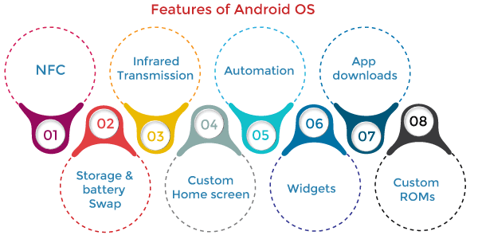
1. Near Field Communication (NFC)
Most Android devices support NFC, which allows electronic devices to interact across short distances easily. The main goal here is to create a payment option that is simpler than carrying cash or credit cards, and while the market hasn't exploded as many experts had predicted, there may be an alternative in the works, in the form of Bluetooth Low Energy (BLE).
2. Infrared Transmission
The Android operating system supports a built-in infrared transmitter that allows you to use your phone or tablet as a remote control.
3. Automation
The Tasker app allows control of app permissions and also automates them.
4. Wireless App Downloads
You can download apps on your PC by using the Android Market or third-party options like AppBrain. Then it automatically syncs them to your Droid, and no plugging is required.
5. Storage and Battery Swap
Android phones also have unique hardware capabilities. Google's OS makes it possible to upgrade, replace, and remove your battery that no longer holds a charge. In addition, Android phones come with SD card slots for expandable storage.
6. Custom Home Screens
While it's possible to hack certain phones to customize the home screen, Android comes with this capability from the get-go. Download a third-party launcher like Apex, Nova, and you can add gestures, new shortcuts, or even performance enhancements for older-model devices.
7. Widgets
Apps are versatile, but sometimes you want information at a glance instead of having to open an app and wait for it to load. Android widgets let you display just about any feature you choose on the home screen, including weather apps, music widgets, or productivity tools that helpfully remind you of upcoming meetings or approaching deadlines.
8. Custom ROMs
Because the Android operating system is open-source, developers can twist the current OS and build their versions, which users can download and install in place of the stock OS. Some are filled with features, while others change the look and feel of a device. Chances are, if there's a feature you want, someone has already built a custom ROM for it.

Architecture of Android OS
The android architecture contains a different number of components to support any android device needs. Android software contains an open-source Linux Kernel with many C/C++ libraries exposed through application framework services.
Among all the components, Linux Kernel provides the main operating system functions to Smartphone and Dalvik Virtual Machine (DVM) to provide a platform for running an android application. An android operating system is a stack of software components roughly divided into five sections and four main layers, as shown in the below architecture diagram.
- Applications
- Application Framework
- Android Runtime
- Platform Libraries
- Linux Kernel
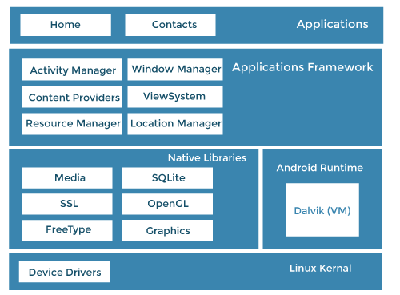
1. Applications
An application is the top layer of the android architecture. The pre-installed applications like camera, gallery, home, contacts, etc., and third-party applications downloaded from the play store like games, chat applications, etc., will be installed on this layer.
It runs within the Android run time with the help of the classes and services provided by the application framework.
2. Application framework
Application Framework provides several important classes used to create an Android application. It provides a generic abstraction for hardware access and helps in managing the user interface with application resources. Generally, it provides the services with the help of which we can create a particular class and make that class helpful for the Applications creation.
It includes different types of services, such as activity manager, notification manager, view system, package manager etc., which are helpful for the development of our application according to the prerequisite.
The Application Framework layer provides many higher-level services to applications in the form of Java classes. Application developers are allowed to make use of these services in their applications. The Android framework includes the following key services:
- Activity Manager: Controls all aspects of the application lifecycle and activity stack.
- Content Providers: Allows applications to publish and share data with other applications.
- Resource Manager: Provides access to non-code embedded resources such as strings, colour settings and user interface layouts.
- Notifications Manager: Allows applications to display alerts and notifications to the user.
- View System: An extensible set of views used to create application user interfaces.
3. Application runtime
Android Runtime environment contains components like core libraries and the Dalvik virtual machine (DVM). It provides the base for the application framework and powers our application with the help of the core libraries.
Like Java Virtual Machine (JVM), Dalvik Virtual Machine (DVM) is a register-based virtual machine designed and optimized for Android to ensure that a device can run multiple instances efficiently.
It depends on the layer Linux kernel for threading and low-level memory management. The core libraries enable us to implement android applications using the standard JAVA or Kotlin programming languages.
4. Platform libraries
The Platform Libraries include various C/C++ core libraries and Java-based libraries such as Media, Graphics, Surface Manager, OpenGL, etc., to support Android development.
- app: Provides access to the application model and is the cornerstone of all Android applications.
- content: Facilitates content access, publishing and messaging between applications and application components.
- database: Used to access data published by content providers and includes SQLite database, management classes.
- OpenGL: A Java interface to the OpenGL ES 3D graphics rendering API.
- os: Provides applications with access to standard operating system services, including messages, system services and inter-process communication.
- text: Used to render and manipulate text on a device display.
- view: The fundamental building blocks of application user interfaces.
- widget: A rich collection of pre-built user interface components such as buttons, labels, list views, layout managers, radio buttons etc.
- WebKit: A set of classes intended to allow web-browsing capabilities to be built into applications.
- media: Media library provides support to play and record an audio and video format.
- surface manager: It is responsible for managing access to the display subsystem.
- SQLite: It provides database support, and FreeType provides font support.
- SSL: Secure Sockets Layer is a security technology to establish an encrypted link between a web server and a web browser.
5. Linux Kernel
Linux Kernel is the heart of the android architecture. It manages all the available drivers such as display, camera, Bluetooth, audio, memory, etc., required during the runtime.
The Linux Kernel will provide an abstraction layer between the device hardware and the other android architecture components. It is responsible for the management of memory, power, devices etc. The features of the Linux kernel are:
- Security: The Linux kernel handles the security between the application and the system.
- Memory Management: It efficiently handles memory management, thereby providing the freedom to develop our apps.
- Process Management: It manages the process well, allocates resources to processes whenever they need them.
- Network Stack: It effectively handles network communication.
- Driver Model: It ensures that the application works properly on the device and hardware manufacturers responsible for building their drivers into the Linux build.

Android Applications
Android applications are usually developed in the Java language using the Android Software Development Kit. Once developed, Android applications can be packaged easily and sold out either through a store such as Google Play, SlideME, Opera Mobile Store, Mobango, F-droid or the Amazon Appstore.
Android powers hundreds of millions of mobile devices in more than 190 countries around the world. It's the largest installed base of any mobile platform and growing fast. Every day more than 1 million new Android devices are activated worldwide.
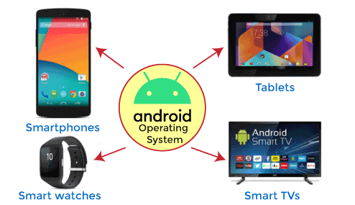

Android Emulator
The Emulator is a new application in the Android operating system. The Emulator is a new prototype used to develop and test android applications without using any physical device.
The android emulator has all of the hardware and software features like mobile devices except phone calls. It provides a variety of navigation and control keys. It also provides a screen to display your application. The emulators utilize the android virtual device configurations. Once your application is running on it, it can use services of the android platform to help other applications, access the network, play audio, video, store, and retrieve the data.

Advantages of Android Operating System
We considered every one of the elements on which Android is better as thought about than different platforms. Below are some important advantages of Android OS, such as:
- Android Google Developer: The greatest favourable position of Android is Google. Google claims an android operating system. Google is a standout amongst the most trusted and rumoured item on the web. The name Google gives trust to the clients to purchase Android gadgets.
- Android Users: Android is the most utilized versatile operating system. More than a billion individuals clients utilize it. Android is likewise the quickest developing operating system in the world. Various clients increment the number of applications and programming under the name of Android.
- Android Multitasking: The vast majority of us admire this component of Android. Clients can do heaps of undertakings on the double. Clients can open a few applications on the double and oversee them very. Android has incredible UI, which makes it simple for clients to do multitasking.
- Google Play Store App: The best part of Android is the accessibility of many applications. Google Play store is accounted for as the world's largest mobile store. It has practically everything from motion pictures to amusements and significantly more. These things can be effortlessly downloaded and gotten to through an Android phone.
- Android Notification and Easy Access: Without much of a stretch, one can access their notice of any SMS, messages, or approaches their home screen or the notice board of the android phone. The client can view all the notifications on the top bar. Its UI makes it simple for the client to view more than 5 Android notices immediately.
- Android Widget: Android operating system has a lot of widgets. This gadget improves the client encounter much and helps in doing multitasking. You can include any gadget relying on the component you need on your home screen. You can see warnings, messages, and a great deal more use without opening applications.

Disadvantages of Android Operating System
We know that the Android operating system has a considerable measure of interest for users nowadays. But at the same time, it most likely has a few weaknesses. Below are the following disadvantages of the android operating system, such as:
- Android Advertisement pop-ups: Applications are openly accessible in the Google play store. Yet, these applications begin demonstrating tons of advertisements on the notification bar and over the application. This promotion is extremely difficult and makes a massive issue in dealing with your Android phone.
- Android require Gmail ID: You can't get to an Android gadget without your email ID or password. Google ID is exceptionally valuable in opening Android phone bolts as well.
- Android Battery Drain: Android handset is considered a standout amongst the most battery devouring operating systems. In the android operating system, many processes are running out of sight, which brings about the draining of the battery. It is difficult to stop these applications as the lion's share of them is system applications.
- Android Malware/Virus/Security: Android gadget is not viewed as protected when contrasted with different applications. Hackers continue attempting to take your data. It is anything but difficult to target any Android phone, and each day millions of attempts are done on Android phones.
IOS is a Mobile Operating System that was developed by Apple Inc. for iPhones, iPads, and other Apple mobile devices. iOS is the second most popular and most used Mobile Operating System after Android.
The structure of the iOS operating System is Layered based. Its communication doesn’t occur directly. The layer’s between the Application Layer and the Hardware layer will help for Communication. The lower level gives basic services on which all applications rely and the higher-level layers provide graphics and interface-related services. Most of the system interfaces come with a special package called a framework.
A framework is a directory that holds dynamic shared libraries like .a files, header files, images, and helper apps that support the library. Each layer has a set of frameworks that are helpful for developers.
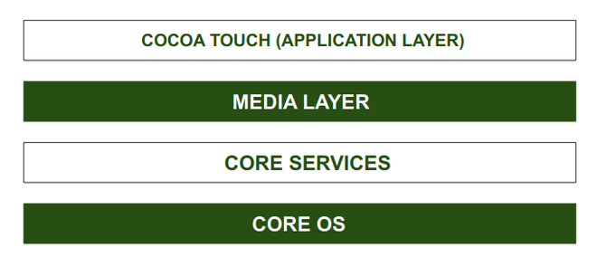
Architecture of IOS
CORE OS Layer:
All the IOS technologies are built under the lowest level layer i.e. Core OS layer. These technologies include:
- Core Bluetooth Framework
- External Accessories Framework
- Accelerate Framework
- Security Services Framework
- Local Authorization Framework etc.
It supports 64 bit which enables the application to run faster.
CORE SERVICES Layer:
Some important frameworks are present in the CORE SERVICES Layer which helps the iOS operating system to cure itself and provide better functionality. It is the 2nd lowest layer in the Architecture as shown above. Below are some important frameworks present in this layer:
- Address Book Framework-
The Address Book Framework provides access to the contact details of the user.
- Cloud Kit Framework-
This framework provides a medium for moving data between your app and iCloud.
- Core Data Framework-
This is the technology that is used for managing the data model of a Model View Controller app.
- Core Foundation Framework-
This framework provides data management and service features for iOS applications.
- Core Location Framework-
This framework helps to provide the location and heading information to the application.
- Core Motion Framework-
All the motion-based data on the device is accessed with the help of the Core Motion Framework.
- Foundation Framework-
Objective C covering too many of the features found in the Core Foundation framework.
- HealthKit Framework-
This framework handles the health-related information of the user.
- HomeKit Framework-
This framework is used for talking with and controlling connected devices with the user’s home.
- Social Framework-
It is simply an interface that will access users’ social media accounts.
- StoreKit Framework-
This framework supports for buying of contents and services from inside iOS apps.
MEDIA Layer:
With the help of the media layer, we will enable all graphics video, and audio technology of the system. This is the second layer in the architecture. The different frameworks of MEDIA layers are:
- ULKit Graphics-
This framework provides support for designing images and animating the view content.
- Core Graphics Framework-
This framework support 2D vector and image-based rendering and it is a native drawing engine for iOS.
- Core Animation-
This framework helps in optimizing the animation experience of the apps in iOS.
- Media Player Framework-
This framework provides support for playing the playlist and enables the user to use their iTunes library.
- AV Kit-
This framework provides various easy-to-use interfaces for video presentation, recording, and playback of audio and video.
- Open AL-
This framework is an Industry Standard Technology for providing Audio.
- Core Images-
This framework provides advanced support for motionless images.
- GL Kit-
This framework manages advanced 2D and 3D rendering by hardware-accelerated interfaces.
COCOA TOUCH:
COCOA Touch is also known as the application layer which acts as an interface for the user to work with the iOS Operating system. It supports touch and motion events and many more features. The COCOA TOUCH layer provides the following frameworks :
- EvenKit Framework-
This framework shows a standard system interface using view controllers for viewing and changing events.
- GameKit Framework-
This framework provides support for users to share their game-related data online using a Game Center.
- MapKit Framework-
This framework gives a scrollable map that one can include in your user interface of the app.
- PushKit Framework-
This framework provides registration support.
Features of iOS operating System:
Let us discuss some features of the iOS operating system-
- Highly Securer than other operating systems.
- iOS provides multitasking features like while working in one application we can switch to another application easily.
- iOS’s user interface includes multiple gestures like swipe, tap, pinch, Reverse pinch.
- iBooks, iStore, iTunes, Game Center, and Email are user-friendly.
- It provides Safari as a default Web Browser.
- It has a powerful API and a Camera.
- It has deep hardware and software integration
Applications of IOS Operating System:
Here are some applications of the iOS operating system-
- iOS Operating System is the Commercial Operating system of Apple Inc. and is popular for its security.
- iOS operating system comes with pre-installed apps which were developed by Apple like Mail, Map, TV, Music, Wallet, Health, and Many More.
- Swift Programming language is used for Developing Apps that would run on IOS Operating System.
- In iOS Operating System we can perform Multitask like Chatting along with Surfing on the Internet.
Advantages of IOS Operating System:
The iOS operating system has some advantages over other operating systems available in the market especially the Android operating system. Here are some of them-
- More secure than other operating systems.
- Excellent UI and fluid responsive
- Suits best for Business and Professionals
- Generate Less Heat as compared to Android.
Disadvantages of IOS Operating System:
Let us have a look at some disadvantages of the iOS operating system-
- More Costly.
- Less User Friendly as Compared to Android Operating System.
- Not Flexible as it supports only IOS devices.
- Battery Performance is po

MS-DOS Operating System
A disk operating system (DOS) is an operating system for x86 based personal computers mostly developed by Microsoft. MS-DOS, its rebranding as IBM PC DOS, and some operating systems attempting to be compatible with MS-DOS. Sometimes it is referred to as "DOS", which is also the generic acronym for disk operating system.
MS-DOS was the main operating system for IBM PC compatible personal computers during the 1980s. It was gradually superseded by operating systems offering a graphical user interface (GUI) in various graphical Microsoft Windows operating system generations.
DOS is also used to describe several similar command-line disk operating systems. Early computers, such as the Commodore 64, Atari 800, and Apple II, all featured a disk operating system, including Commodore Business Machines DOS, Atari DOS, and Apple DOS, respectively. DOS/360 was an OS for IBM mainframes, which first appeared in 1966, but it is unrelated to the 8086-based DOS of the 1980s.
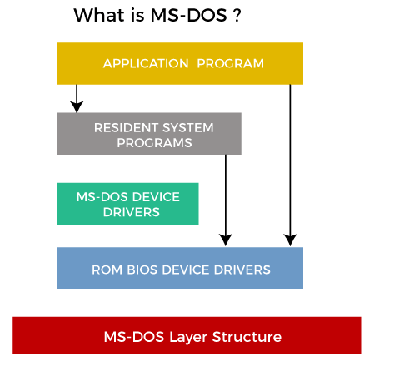
Several competing products were released for the x86 platform during its lifetime, and MS-DOS went through eight versions until development ceased in 2000. Initially, MS-DOS was targeted at Intel 8086 processors running on computer hardware using floppy disks to store and access the operating system, application software, and user data.
Progressive version releases delivered support for other mass storage media in ever greater sizes and formats and added feature support for newer processors and rapidly evolving computer architectures. Microsoft's development was the key product from a programming language company to a diverse software development firm, providing essential revenue and marketing resources. It was also the underlying basic operating system on which early versions of Windows ran as a GUI.

How DOS works?
When a computer is powered on, it goes through various steps called the boot process. For a computer running a disk operating system in the following six steps, such as:
- The read-only memory (ROM) bootstrap loader reads the Master Boot Record and passes control over to it.
- The boot record loads the disk operating system into memory, and it takes control of the machine.
- The computer transfers data stored on a magnetic disk to its main memory, the random access memory.
- It also transfers data to external devices attached to the computer, such as a computer screen or printer.
- The computer provides various applications programming interfaces for programs like character input/output, memory management, program loading, termination, and handling input from the user through a keyboard.
- The OS also provides file management that organizes, reads, and writes files on storage. The files are organized in a hierarchical structure of directories, subdirectories, and files.
A disk operating system doesn't have a graphical user interface (GUI). Its interface is character-based, so users must type commands in the command line to indicate what actions they want.

Features of DOS
Here are some of the distinguishing features of a disk operating system, such as:
- MS-DOS does not offer GUI (Graphical User Interface) and doesn't accept mouse inputs. It is a character-based interface system where all commands are entered in the text at the command-line prompt.
- A disk operating system manages files, folders and allows program loading and execution. It can control hardware devices such as disk, memory and allocate resources.
- MS-DOS offers a file system to organize, read and write files to the disk storage.
- It is a single-user operating system and performs various tasks to ensure the proper operation of systems.
- It uses a 16-bit file allocation table (FAT16), and a 16-bit interface is used to define the location of the memory of each file uniquely. These identifiers are stored in a tabular format with the name File Allocation table.
- MS-DOS does not support a multiuser operating system, and it is less secure and does not have a concept of user roles. It is very lightweight due to its basic interface and limited features.

Limitations of MS-DOS
Here are the following limitations of the disk operating system, such as:
- Built-in security:DOS does not have built-in security, such as file ownership and permissions.
- No multiuser or multitasking:It also does not support multiuser or multitasking. It can only run one program at a time, but it provides direct access to the basic I/O system and underlying hardware.
- Challenging interface: A user must type in commands and remember commands to run programs and other OS tasks. For example, typing the command cd \directory_name changes the current working directory to the named directory, and typing the command dir lists the files in the current directory. This approach makes it difficult for beginners to use.

Types of MS-DOS Commands
An instruction given to a computer to perform a specific task is known as a command. The MS-DOS has many commands to perform each task, and these commands are stored in the DOS directory of the disk. The MS-DOS commands are of two types, internal command, and external command.
- Internal Command: Internal commands are built-in commands of MS-DOS, stored in the command interpreter file (COMMAND.COM). These commands reside in memory if the system is at prompt (C:\>) level. Some of the internal commands are DATE, TIME, DIR, VER, etc.
- External Command: External commands are separate program (.com) files that reside in the DOS directory.
MS-DOS is not case-sensitive so that commands can type in either uppercase or lowercase. However, other disk operating systems have case-sensitive CLIs. DOS commands include the following.
Commands | Description
Dir | List all files of specific directories or subdirectories.
CD or CHDIR | Navigate or move to a specific directory.
RD or RMDIR | Remove directory.
TREE | Display all directory paths.
PATH | Set sequential search path for executable files.
SUBST | Substitutes a string alias for the pathname.
FORMAT | Formats a disk for DOS files.
COPY | Copies one or more files to another location.
XCOPY | Copy files and directories and their subdirectories.
Del | Delete files.
Ren or rename | Rename the name of a file or directory.
ATTRIB | Set or show file attributes.
BACKUP | Backup files and directories.
PROMPT | Customize DOS prompt.
Deltree | Deletes all files and subdirectories from a computer.
Help | Lists the available commands or more information about a specific command.
mkdir or md | Creates a new subdirectory.
Move | Moves files or directories from one directory to another or from one drive to another.
Type | Displays the contents of a file on the screen.
* | A wildcard character that represents one or more characters a group of files has in common.
? | A wildcard character that represents a single character a group of files has in common.

MS-DOS Files and Filenames
One of the primary functions of the OS is to handle disk files. A file can contain only data, or it can contain a set of instructions, called a program, telling the computer how to perform a particular task. Every file has associated with it a unique filename which is used to identify it on the disk. A filename in MS-DOS has two parts; the name and an extension.
The name can contain up to eight characters. Each filename can have a three-character extension. The extension is separated from the name by a period. The period serves as a delimiter, indicating where one portion of the filename ends, and the next begins. An extension is usually used to identify files that are related in some way. MS-DOS allows the following characters to be used in a filename and extension:
- Uppercase and lowercase case letters A through Z
- Numbers 0 through 9
- Special characters $ # & @ ( ) ! ^ ` ~ { }
Any other character used in a filename, including spaces, will cause the name to be terminated at that character. It is generally good practice not to use special characters in filenames because some programs may use them as delimiters or other special purposes.
In addition, the extensions BAT, COM, EXE, and SYS have special meanings in MS-DOS and should therefore normally not be used with your data files. Shown below are examples of both valid and unacceptable filenames.
Valid MS-DOS Filenames:
- BEERSLAW
- DAT
- 1
- EXP
Invalid MS-DOS Filenames:
- EXP 1.DAT (space is not allowed)
- BEERSLAWDATA (too many characters in the name)
- EXP1 (too many characters in the extension)
- HG>HE (> is an invalid character)

Difference between DOS and UNIX
In this article, you will learn the difference between the DOS and UNIX operating systems. But before discussing the differences, you will need to know about the DOS and UNIX.

What is DOS?
DOS stands for a Disk Operating System. It is a computer operating system that was used in Microsoft's x86-based PCs. The Disk Operating System (DOS) was released in 1981, and it was a single-processing operating system. X86-based PCs are Microsoft Corporation-expanded personal computers. The hard drive device will be used to run DOS. MS-DOS was renamed IBM PC DOS, and several operating systems were suited with MS-DOS and referred to as DOS.
The Disk Operating System (DOS) contains C Programming Language, Assembly Language, and x86-based language. The Microsoft Corporation and Tim Paterson develop the Disk Operating System. Microsoft created the x86-based computers, which run on the DOS. The source models were available in DOS format. DOS was first introduced in 1981, while Windows 8.0 was released in 2000. Since 2018, the DOS has close source and open-source versions for selected versions.
DOS is a mono-spaced raster typeface with a font size that is comparable to Courier. This type of font size was intended as an MS-DOS typeface and utilized cross zeros. Deltree is the command used for external code, whereas Dir was used for internal code. Disk Operating System (DOS) was used for personal computers before Windows had arrived. It is a single-command operating system that cannot handle multiple commands. DOS can be used to access disk storage devices, including optical disks, floppy disks, and hard disk drives. Operating disk drives help in the organization of file systems for reading and writing to disk storage.
Features of DOS
There are various features of the disk operating system. Some features of the operating system are as follows:
- It is a free OS.
- It is a 16-bit OS.
- It aids make file management, e.g., creating, editing, deleting files, etc.
- It doesn't support GUI.
- It is a single-user OS.
- It has a text-based interface and operates completely on text and codes.

What is UNIX?
UNIX is a computer OS that supports multiple processors. UNIX was derived from the original AT&T UNIX system, which was designed and developed in the 19th century. The UNIX operating system was created by FreeBSD, Brian Kernighan, Nokia Bell Labs, Douglas Mcllroy, Ken Thomson, Dennis Ritchie, and Joe Ossanna. Plan 9 and Linux are two OS versions of the UNIX OS.
The C and Assembly languages were used to develop the UNIX OS. UNIX was first introduced on November 3, 1971, and the Turning Award was later given to this operating system. UNIX OS uses servers to run medium-to-large-scale computer systems. The servers used for the UNIX operating system are Application Servers and Database Servers. The servers include SUN, IBM, HP, and some others.
UNIX is a multi-purpose operating system that may be used on desktops, laptops, and servers. The UNIX end-of-line system is known as ("/n"). UNIX is made up of environment variables, some of which are set by the system. The user controls some variables, while the shell and program control others. The UNIX operating system contained a regular expression with characters in the sequence that matched the text. The UNIX operating system contains multitasker and multiuser features.
UNIX offers a graphical user interface that is comparable to that of Windows. The abbreviation for UNIX is UNICS, which stands for UNiplexed Information Computing System. It began working on programming in the 1960s and became operational in 1971. The UNIX operating system has been widely utilized in complicated, critical applications for some companies. Data Enterprise Centre prefers the UNIX OS.

Advantages and Disadvantages of UNIX Operating System
There are various advantages and disadvantages of a UNIX operating system. Some of the advantages and disadvantages of the UNIX operating system are as follows:
Advantages
- If you want to run complex programs, UNIX operating system uses less memory. UNIX operating system may manage virtual memory very effectively. The virtual memory grows as additional programs are loaded into the main memory. In UNIX, most of the jobs are completed with fewer resources.
- Many online stores operate their websites on UNIX or Linux servers. UNIX has also been used to manage mobile phones and other electrical systems.
- Since the UNIX operating system is free and safe, it is commonly used by web hosting providers. Various web hosting servers use utilities such as DHCP (Dynamic Host Configuration Protocol), DNS (Domain Name Server), and the webserver.
- UNIX operating system offers a safe and secure platform for various users to interact with servers online without any security breaches. UID and GID control users' permissions in UNIX and files are accessed through these permissions. The interaction with the UNIX servers is quick and error-free.
- Since the UNIX operating system is written in C, so it is a highly portable operating system. It is suitable for both personal computers and MAC machines. C is a famous programming language, and most programmers may easily work in it. The C programming language may be used to interface with hardware.
- If you've worked with MS-DOS on Windows, you'll find that UNIX is easy to use. The user interface and command usage are quite similar to MS-DOS.
Disadvantages
- There is no proper documentation for UNIX. If the user finds an issue, he must seek the advice of an expert because getting online assistance from the documentation is difficult. When compared to Windows and macOS, you will find proper and easy documentation available online.
- UNIX commands are far more difficult to learn than the other operating systems like Windows, MS-DOS, and macOS. It is also tough to recall the commands. You must first read the documentation every time you need to use a difficult command. The new UNIX OS includes a graphical user interface (GUI), although most work is still done via the command-line interface (CLI). UNIX apps and software are also not widely used, and you must learn them before utilizing this software.
- UNIX is difficult to use for a beginner. Beginners must memorize various commands because CLI commands are used for most of the UNIX work. Some people with a lot of experience have trouble utilizing commands since the names of some commands are extremely different. UNIX is designed mainly for programmers, not for beginners.
- Most UNIX commands employ cryptic words. It is tough for beginners to understand how commands work. Some commands employ unusual characters, making it difficult for inexperienced programmers to grasp them. If you type the wrong character in the command, your system will begin performing unknown tasks, including deleting or changing data on your computer. Some UNIX commands function in conjunction with other commands, so your task will be incomplete if you forget one.

Key differences between the DOS and UNIX operating system
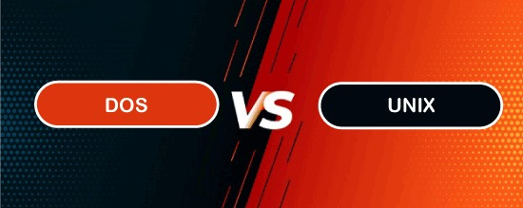
There are various main differences between the DOS and UNIX operating systems. Some of the main differences between the DOS and UNIX operating systems are as follows:
- DOS is an operating system that is only used in x86-based computers. On the other hand, UNIX is an operating system that is used in all types of computers.
- DOS is a single command-line system. On the other hand, UNIX operating system is a multitasking, multiuser system.
- DOS was firstly released in 1981. On the other hand, the UNIX operating system was firstly released in November 1971.
- DOS operates from a hard disk device. On the other hand, the UNIX operating system was installed after being obtained from the original AT&T UNIX.
- DOS contains three proprietary versions (MS-DOS, IBM DOS, and DR-DOS) and one free version (FreeDOS). On the other hand, UNIX operating system has numerous proprietary and free/open-source implementations.
- DOS is an abbreviation for Disk Operating System. On the other hand, UNIX operating system is an abbreviation for UNiplexed Information Computing System.
- DOS has no native support for IP networks. On the other hand, UNIX operating system comes with built-in support for IP networks.
- DOS contains batch files. On the other hand, UNIX operating system contains shell files.

Head-to-head comparison between the DOS and UNIX operating system
There are various head-to-head comparisons between the DOS and UNIX operating systems. Some of the main head-to-head comparisons of the DOS and UNIX operating systems are as follows:
DOS | UNIX Operating System
It is only used in x86-based computer systems. | It is used in all types of computer systems.
It is a single command-line OS. | It is a multitasking OS.
It was firstly released in 1981. | It was firstly released in November 1971.
It is an abbreviation for Disk Operating System. | It is an abbreviation for UNiplexed Information Computing System.
Disk operating system consumes low power. | UNIX operating system consumes high power.
DOS is not case-sensitive. | UNIX OS is case-sensitive.
Disk operating system uses the backslashes. | UNIX operating system uses forward slashes.
It operates from a hard disk device. | It was installed after being obtained from the original AT&T UNIX.
DOS contains batch files. | UNIX operating system contains shell files.
DOS contains three proprietary versions (IBM DOS, MS-DOS, and DR-DOS) and one free version (FreeDOS). | UNIX operating system contains numerous proprietary and free, and open-source implementations.
It is mainly used in embedded systems. | UNIX operating system is mainly used in servers.
DOS has neither virtual memory nor protected memory. | UNIX operating system usually has virtual memory and protected memory.

Conclusion
In this article, you have learned the difference between the disk and UNIX operating systems. Disk operating system and UNIX operating system are different from each other. Disk operating system is mainly used in embedded devices and X86-based processor systems. In contrast, the UNIX operating system is used in all computer systems and servers. The other difference is that the Disk operating system is a single processing system. On the other hand, UNIX operating system is a multiprocessing system.

Unix Vs Linux
Today Linux is in great demand. You can see the use of Linux everywhere. It's dominating on our servers, desktop, smartphones and even used in some electrical devices like refrigerators.
Some people think Unix and Linux as synonyms, but that's not true. Many operating systems were developed to be like Unix but none of them got the popularity as Linux. Linux is the clone of Unix. It has several features similar to Unix, still have some key differences. Before Linux and Windows, computer world was dominated by Unix. Unix is a copyrighted name and IBM AIX, HP-UX and Sun Solaris are only Unix operating system remained till date.

Introduction to Unix
Unix is a family of multiuser, multitasking computer OSes that derive from the actual AT&T Unix, whose integration started in 1969 at the Bell Labs research center by Dennis Ritchie, Ken Thompson, and others. Unix was intended for use in the Bell system initially, leading to a range of both commercial and academic Unix versions from vendors, including IBM (AIX), HP/HPE (HP-UX), Sun Microsystems (Solaris/SunOS), Berkeley (BSD), Microsoft (Xenix), and the University of California.
Unix systems are designated by a modular design sometimes known as the "Unix philosophy". The operating system should give a group of simple tools according to this philosophy, all of which perform a well-defined and limited function. An incode, unified-based file system and an inter-process communication technique called "pipes" serve as the primary communication means, and a command and shell scripting language is used to merge the tools to implement complex workflows.
Unix differentiates itself from its predecessors as the initial portable OS; almost the whole operating system is specified in the C programming language, which permits Unix to run on numerous platforms.

Components of Unix
The Unix system consists of several components that were actually packaged together. By adding the development environment, documents, libraries, and the modified, portable source code for each of these components, in inclusion to the kernel of an OS, Unix was an autonomous software system.
The filesystem locations and names of the Unix components have substantially changed across the system history. Nonetheless, the implementation of the 7 version is considered by several for having the early structure of Canonical:
- Kernel: It is composed of many sub-components, and its source code resides in the /usr/sys directory.
- Development environment: The recent versions of Unix included a development environment acceptable for remaking the whole system from the source code.
- Commands: Unix makes a distinction between user-level programs or commands for system maintenance and operation, general utility commands, and more general-purpose software like typesetting packages and text formatting.
- Documentation: Unix was one of the initial OSes to add each of its documentation online inside the machine-readable format.

Introduction to Linux
Linux is a family of Unix-like open-source operating systems. Typically, Linux is packaged as the Linux distribution, which contains the supporting system libraries and software and the Kernel, several of which are offered by the GNU Project. Several Linux distributions utilize the word "Linux", but the Free Software Foundation utilizes the "GNU/Linux" name to focus on the GNU software importance.
Famous Linux distributions are Ubuntu, Fedora Linux, and Debian, the latter of which itself composed of several different distributions and changes, including Xubuntu and Lubuntu. Commercial distributions are SUSE Linux Enterprise and Red Hat Enterprise Linux. Desktop Linux distributions are windowing systems like Wayland or X11 and desktop environments like KDE Plasma or GNOME.
Linux is one of the most outstanding examples of open-source and free software collaboration. Linux source code may be distributed, modified, and used non-commercially or commercially by anyone upon the terms of its respective licenses, like the GPL (GNU General Public License). For example, the Linux Kernel is licensed upon the GPLv2.

Components of Linux
Installed components of the Linux System contain the following:
- Bootloader: It is a program that can load the Linux Kernel into the main memory of the computer by being run by the system after the initialization of the firmware is performed and when it's turned on.
- Init program: It is the initial process begun by the Linux Kernel.
Software libraries: These include code that can be used by active processes.
- Basic Unix commands: Basic Unix commands, along with GNU coreutils, are the typical implementation. Several alternatives are available for embedded systems, like BSD-licensed Toybox and the copyleft BusyBox.
- Widget toolkits: They are the libraries utilized to create graphical user interfaces for software applications. Several widget toolkits are present, including Clutter and GTK integrated by the GNOME Project, Qt integrated by the Qt Project and conducted by the Enlightenment Foundation Libraries (EFL), and the Qt company primarily developed by the Enlightenment team.
- Package management system: The package management system includes RPM and dpkg. The packages can alternatively be compiled from source and binary tarballs.
- User interface program: The user interface programs are also available in Linux, such as windowing environments or command shells.

Difference between Linux and Unix
Comparison | Linux | Unix
Definition | It is an open-source operating system which is freely available to everyone. | It is an operating system which can be only used by its copyrighters.
Examples | It has different distros like Ubuntu, Redhat, Fedora, etc | IBM AIX, HP-UX and Sun Solaris.
Users | Nowadays, Linux is in great demand. Anyone can use Linux whether a home user, developer or a student. | It was developed mainly for servers, workstations and mainframes.
Usage | Linux is used everywhere from servers, PC, smartphones, tablets to mainframes and supercomputers. | It is used in servers, workstations and PCs.
Cost | Linux is freely distributed,downloaded, and distributed through magazines also. And priced distros of Linux are also cheaper than Windows. | Unix copyright vendors decide different costs for their respective Unix Operating systems.
Development | As it is open source, it is developed by sharing and collaboration of codes by world-wide developers. | Unix was developed by AT&T Labs, various commercial vendors and non-profit organizations.
Manufacturer | Linux kernel is developed by the community of developers from different parts of the world. Although the father of Linux, Linus Torvalds oversees things. | Unix has three distributions IBM AIX, HP-UX and Sun Solaris. Apple also uses Unix to make OSX operating system.
GUI | Linux is command based but some distros provide GUI based Linux. Gnome and KDE are mostly used GUI. | Initially it was command based OS, but later Common Desktop Environment was created. Most Unix distributions use Gnome.
Interface | The default interface is BASH (Bourne Again SHell). But some distros have developed their own interfaces. | It originally used Bourne shell. But is also compatible with other GUIs.
File system support | Linux supports more file system than Unix. | It also supports file system but lesser than Linux.
Coding | Linux is a Unix clone,behaves like Unix but doesn't contain its code. | Unix contain a completely different coding developed by AT&T Labs.
Operating system | Linux is just the kernel. | Unix is a complete package of Operating system.
Security | It provides higher security. Linux has about 60-100 viruses listed till date. | Unix is also highly secured. It has about 85-120 viruses listed till date
Error detection and solution | As Linux is open-source,whenever a user post any kind of threat, developers from all over the world start working on it. And hence, it provides faster solution. | In Unix, users have to wait for some time for the problem to be resolved.

- Optional

Components of Operating System
An operating system is a large and complex system that can only be created by partitioning into small parts. These pieces should be a well-defined part of the system, carefully defining inputs, outputs, and functions.
Although Windows, Mac, UNIX, Linux, and other OS do not have the same structure, most operating systems share similar OS system components, such as file, memory, process, I/O device management.
The components of an operating system play a key role to make a variety of computer system parts work together. There are the following components of an operating system, such as:
- Process Management
- File Management
- Network Management
- Main Memory Management
- Secondary Storage Management
- I/O Device Management
- Security Management
- Command Interpreter System
Operating system components help you get the correct computing by detecting CPU and memory hardware errors.
Backward Skip 10sPlay VideoForward Skip 10s
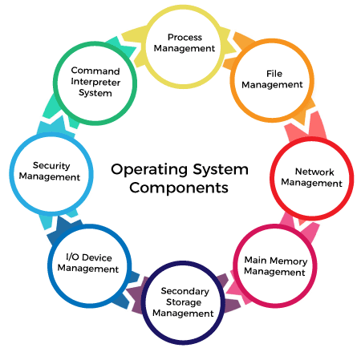

Process Management
The process management component is a procedure for managing many processes running simultaneously on the operating system. Every running software application program has one or more processes associated with them.
For example, when you use a search engine like Chrome, there is a process running for that browser program.
Process management keeps processes running efficiently. It also uses memory allocated to them and shutting them down when needed.
The execution of a process must be sequential so, at least one instruction should be executed on behalf of the process.
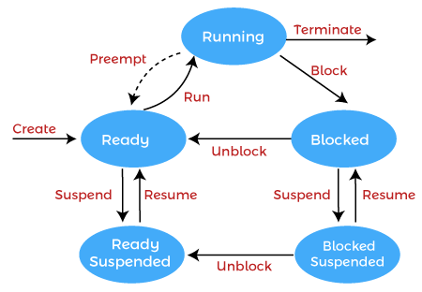
Functions of process management
Here are the following functions of process management in the operating system, such as:
- Process creation and deletion.
- Suspension and resumption.
- Synchronization process
- Communication process

NOTE: OS facilitates an exchange of information between processes executing on the same or different systems.

File Management
A file is a set of related information defined by its creator. It commonly represents programs (both source and object forms) and data. Data files can be alphabetic, numeric, or alphanumeric.
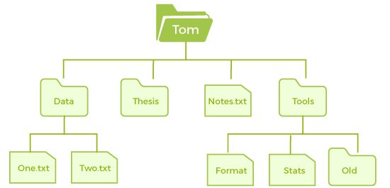
Function of file management
The operating system has the following important activities in connection with file management:
- File and directory creation and deletion.
- For manipulating files and directories.
- Mapping files onto secondary storage.
- Backup files on stable storage media.

Network Management
Network management is the process of administering and managing computer networks. It includes performance management, provisioning of networks, fault analysis, and maintaining the quality of service.
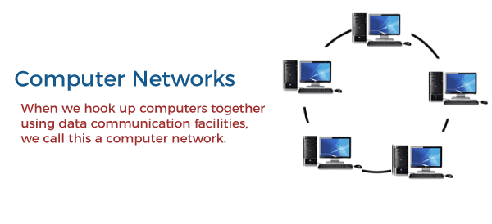
A distributed system is a collection of computers or processors that never share their memory and clock. In this type of system, all the processors have their local memory, and the processors communicate with each other using different communication cables, such as fibre optics or telephone lines.
The computers in the network are connected through a communication network, which can configure in many different ways. The network can fully or partially connect in network management, which helps users design routing and connection strategies that overcome connection and security issues.
Functions of Network management
Network management provides the following functions, such as:
- Distributed systems help you to various computing resources in size and function. They may involve minicomputers, microprocessors, and many general-purpose computer systems.
- A distributed system also offers the user access to the various resources the network shares.
- It helps to access shared resources that help computation to speed up or offers data availability and reliability.

Main Memory management
Main memory is a large array of storage or bytes, which has an address. The memory management process is conducted by using a sequence of reads or writes of specific memory addresses.
It should be mapped to absolute addresses and loaded inside the memory to execute a program. The selection of a memory management method depends on several factors.
However, it is mainly based on the hardware design of the system. Each algorithm requires corresponding hardware support. Main memory offers fast storage that can be accessed directly by the CPU. It is costly and hence has a lower storage capacity. However, for a program to be executed, it must be in the main memory.
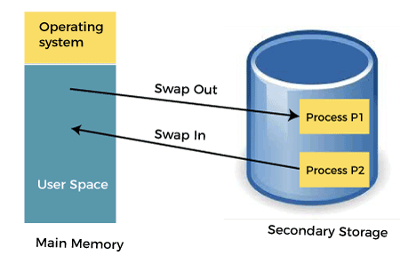
Functions of Memory management
An Operating System performs the following functions for Memory Management in the operating system:
- It helps you to keep track of primary memory.
- Determine what part of it are in use by whom, what part is not in use.
- In a multiprogramming system, the OS decides which process will get memory and how much.
- Allocates the memory when a process requests.
- It also de-allocates the memory when a process no longer requires or has been terminated.

Secondary-Storage Management
The most important task of a computer system is to execute programs. These programs help you to access the data from the main memory during execution. This memory of the computer is very small to store all data and programs permanently. The computer system offers secondary storage to back up the main memory.
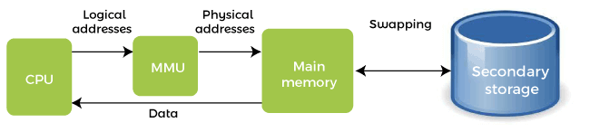
Today modern computers use hard drives/SSD as the primary storage of both programs and data. However, the secondary storage management also works with storage devices, such as USB flash drives and CD/DVD drives. Programs like assemblers and compilers are stored on the disk until it is loaded into memory, and then use the disk is used as a source and destination for processing.
Functions of Secondary storage management
Here are some major functions of secondary storage management in the operating system:
- Storage allocation
- Free space management
- Disk scheduling

I/O Device Management
One of the important use of an operating system that helps to hide the variations of specific hardware devices from the user.
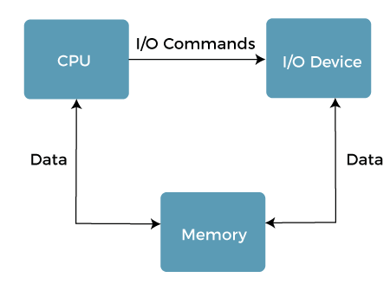
Functions of I/O management
The I/O management system offers the following functions, such as:
- It offers a buffer caching system
- It provides general device driver code
- It provides drivers for particular hardware devices.
- I/O helps you to know the individualities of a specific device.

NOTE: The user's program can't execute I/O operations directly. The operating system should provide some medium to perform this.

Security Management
The various processes in an operating system need to be secured from other activities. Therefore, various mechanisms can ensure those processes that want to operate files, memory CPU, and other hardware resources should have proper authorization from the operating system.
Security refers to a mechanism for controlling the access of programs, processes, or users to the resources defined by computer controls to be imposed, together with some means of enforcement.
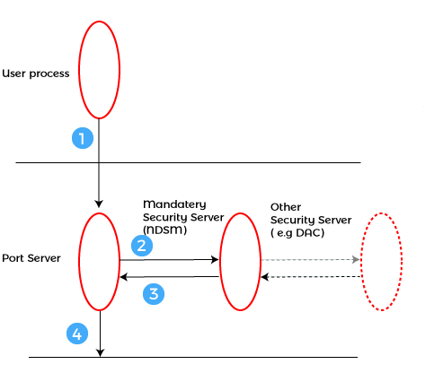
For example, memory addressing hardware helps to confirm that a process can be executed within its own address space. The time ensures that no process has control of the CPU without renouncing it. Lastly, no process is allowed to do its own I/O to protect, which helps you to keep the integrity of the various peripheral devices.
Security can improve reliability by detecting latent errors at the interfaces between component subsystems. Early detection of interface errors can prevent the foulness of a healthy subsystem by a malfunctioning subsystem. An unprotected resource cannot misuse by an unauthorized or incompetent user.

Command Interpreter System
One of the most important components of an operating system is its command interpreter. The command interpreter is the primary interface between the user and the rest of the system.
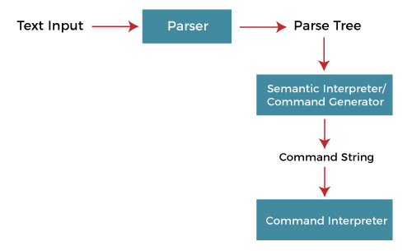
Many commands are given to the operating system by control statements. A program that reads and interprets control statements is automatically executed when a new job is started in a batch system or a user logs in to a time-shared system. This program is variously called.
- The control card interpreter,
- The command-line interpreter,
- The shell (in UNIX), and so on.
Its function is quite simple, get the next command statement, and execute it. The command statements deal with process management, I/O handling, secondary storage
management, main memory management, file system access, protection, and networking.

